- Copyright for test papers and marking guides remains with West Australian Test Papers.
- The papers may only be reproduced within the purchasing school according to the advertised conditions of sale.
- Test papers must be withdrawn after use and stored securely in the school until Friday 3rd December 2010.



YEAR 11 PHYSICS

STAGE 2A/2B

2010

MARKING GUIDE

Structure of this paper

Section | Number of questions available | Number of questions to be answered | Suggested working time  (minutes) | Percentage of exam | Marks available
Section One:  Short answers | 17 | 17 | 70 | 40% | 64
Section Two:  Problem-solving | 7 | 7 | 90 | 50% | 80
Section Three:  Comprehension | 1 | 1 | 20 | 10% | 16
 |  |  |  |  | 160

Raw exam score: ____________

Marks removed for inappropriate significant figures = ____________

Marks removed for inappropriate units = _____________________
Total = _________

Note: a maximum of 4 marks can be removed for inappropriate use of units (including vector direction) and significant figures in the final answers to numerical problems.

Instructions to candidates

1. The rules for the conduct of Western Australian external examinations are detailed in the Year 12 Information Handbook 2010. Sitting this examination implies that you agree to abide by these rules.

2. Write your answers in this Question/Answer Booklet.

3. Working or reasoning should be clearly shown when calculating or estimating answers.

4. It is suggested that final answers to calculations be given to 3 significant figures unless you are required to estimate, in which case an appropriate number of significant figures must be used.

5. You must be careful to confine your responses to the specific questions asked and to follow any instructions that are specific to a particular question.

6. Spare pages are included at the end of this booklet. They can be used for planning your responses and/or as additional space if required to continue an answer.
  - Planning: If you use spare pages for planning, indicate this clearly at the top of the page.
  - Continuing an answer: If you need to use the space to continue an answer, indicate in the original answer space where the answer is continued, i.e. give the page number. Fill in the number of the question(s) that you are continuing to answer at the top of the page.

Section One: Short answer 40% (64 Marks)

This section has 17 questions. Answer all questions. Write your answers in the space provided. Suggested working time for this section is 70 minutes.

Question 1 (3)

On hot summer days at the beach you can sometimes see people relaxing on a deck chair with a wet cloth over their forehead. Referring to heat energy concepts, explain how a wet cloth placed on the forehead can help a person stay cool.
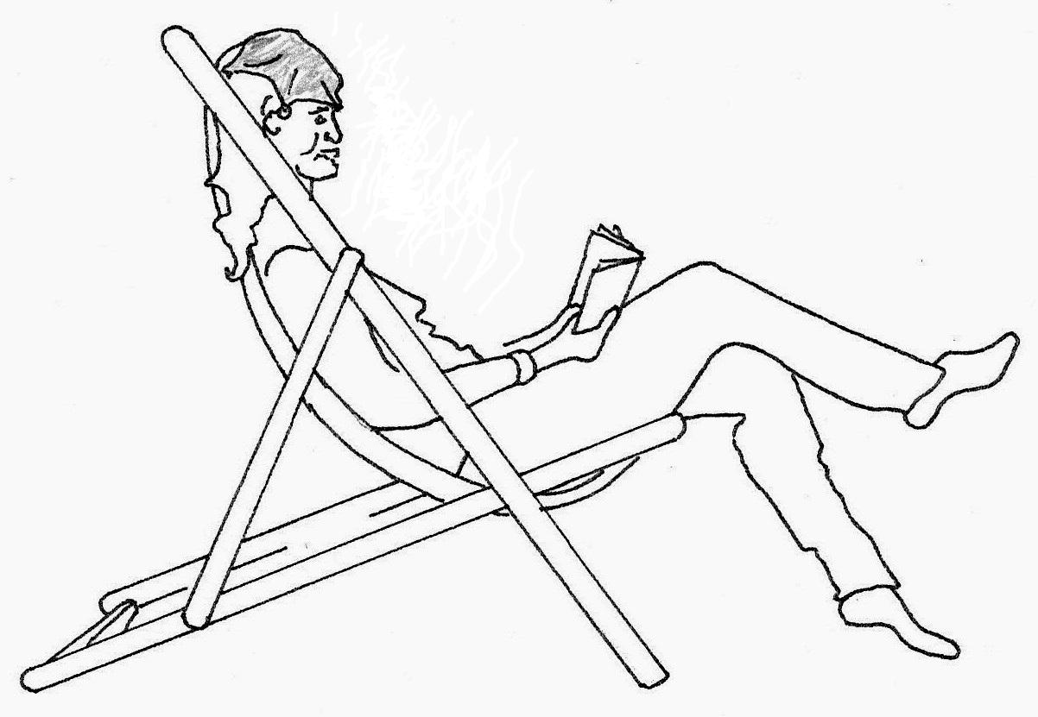
Wet Cloth

Water in the wet cloth evaporates. ✓

Energy needed for the phase change, the latent heat of vaporisation, is taken from the forehead. ✓ This lowers the temperature of the forehead. ✓
Or – water particles with higher Kinetic Energy escape from the cloth/forehead lowering the average kinetic energy of particles, hence lowering temperature.

Question 2
- When a resistor is connected to a battery, 1.57 × 10²¹ electrons pass through the resistor in a time of 90 seconds. Calculate the current in the resistor.
(2)
Q = q_{e} × n_{e} = -1.60 × 10⁻¹⁹ × 1.57 × 10²¹ = 251.2 C (scalar), t = 90 s ✓
I = Q / t
I = 251.2 / 90
I = 2.80 A ✓

Resistor

- Put a labelled arrow on the diagram to indicate the direction of net electron drift in this circuit.

Also, put a labelled arrow on the diagram to indicate the direction of conventional current in this circuit.
(1)

Question 3 (3)
A blacksmith heated a 950 g stainless steel horseshoe in a furnace until it reached a temperature of 749°C. He plunged the horseshoe into 3.20 L of water. The final temperature of the steel and water mixture was 43.3°C when they reached thermal equilibrium.

Calculate the energy that transferred out of the horseshoe into the water.

Variables SI units: m_{i}= 0.950 kg c = 4.45×10² J Kg⁻¹ K⁻¹ (data sheet) ΔT = 43.3 -749 = -705.7✓
Q = m_{i} .c.ΔT
Q = (0.950 × 4.45×10² × -705.7) ✓
Q = -298,334.675 J
Q = 2.98 × 10⁵ J transferred out✓

Question 4
A sample of skull bone from a recently deceased human was tested and found to have an activity of 0.320 Bq. A similar size sample was obtained from a human skull uncovered at an archaeological site and its activity was measured. Over a one hour period 324 counts were registered on a Geiger counter. The half life of radioactive carbon is approximately 5730 years.

(a) Determine the activity (becquerels) for the archaeological sample.
(1)
Activity = decays per second 1 hour = 60 × 60 = 3600 seconds
A = 324 / 3600 = 0.09 Bq ✓

(b) Determine the age of the skull from the archaeological site.
A = 0.09 Bq A₀ = 0.320 Bq t_{½} = 5730 years
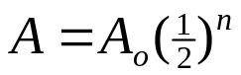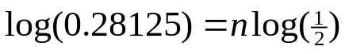
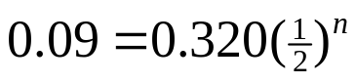 ✓ 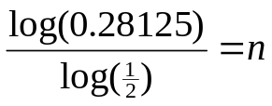
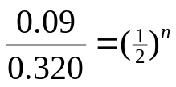 n = 1.83 ✓
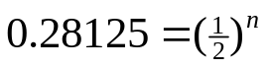 t = n × t_{½}
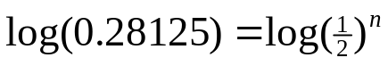 t = 1.83 × 5730 = 10,485.9
Age t = 10,500 years ✓
Or guess check and improve method if used by your school
0.32 ➔0.16➔0.08 = 2 half lives, so a little less than 11,460 yrs
(3)

Question 5 [4]
Write balanced nuclear equations for the following decays:

- Sodium-24 (Na-24) by beta negative decay.

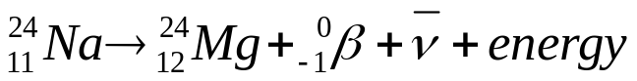 Balances top and bottom✓ correct symbols✓

- Thorium-232 (Th-232) by alpha decay.

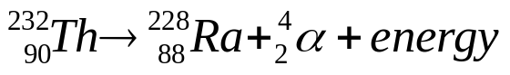 Balances top and bottom✓ correct symbols✓

Question 6
A helicopter of mass 3100 kg is kept at a constant height and propelled forwards by a single force from its rotors acting at an angle of 20.8 ° to the vertical.

- Draw a vector diagram and determine the magnitude of the force from the rotors.
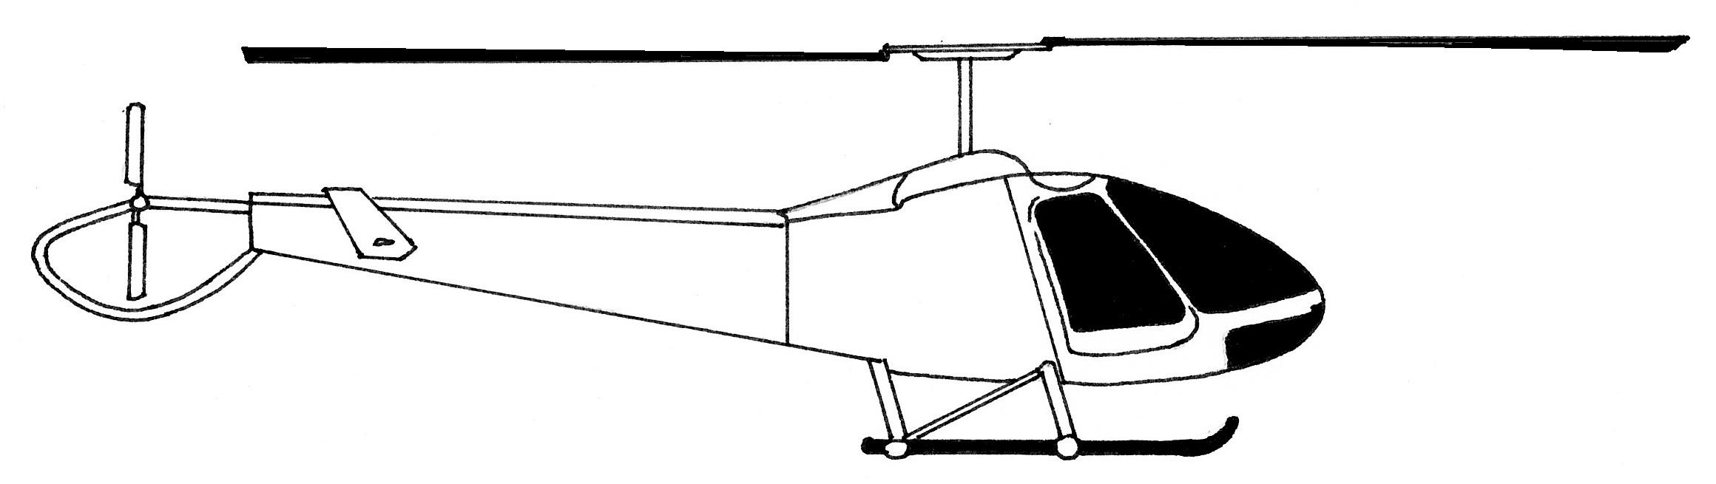
20.8°
Force from rotors acts at an angle of 20.8° to the vertical

W = mg
W = 3100 × 9.8
W = 30 380 N
20.8°
F_{rotor} diagram ✓

(3)

cos 20.8° = 30 380 / F_{rotor}
F_{rotor} = 30 380 / cos 20.8° ✓

F_{rotor} =32 498.03762 F_{rotor} = 3.25 × 10⁴ N ✓

b) Calculate the work done by the force from the rotors to move the helicopter horizontally forwards by a distance of 65.0 m.
(If you could not solve part a) let the force from the rotors = 3.00 × 10⁴ N)

(2)
F_{rotor} =32 498.03762 s = +65.0 m θ = 20.8°
Concept, work done by F_{component} in direction of displacement
W = F_{rotor} × sin θ × s
W = 32 498.03762 × sin 20.8° × 65 ✓ = 750 118.1625

W = 7.50 × 10⁵ J ✓

Question 7 (3)
Wine glass
Cracks in the glass where it has come into contact with hot water
If a thin walled drinking glass (such as a wine glass) is dipped into very hot water the glass often cracks.

Referring to the principles of Kinetic Molecular Theory, explain why this happens.

This is due to thermal expansion and the fact that glass is a heat insulator.
- Placement of the glass into hot water causes a transfer of heat energy into glass. ✓
- The glass expands (an increase in potential energy)✓.
- The glass is an insulator so cannot distribute the energy quickly and expansion remains localised, this causes the glass to crack (thermal shock). ✓

Question 8
- Explain why the metal copper is a better electrical conductor than rubber. (2)
Copper has delocalised negatively charged electrons. ✓
They can be influenced to move by an electric force field through the copper material. ✓ Or similar

- Explain why the metal copper is a better heat conductor than rubber. (2)

The delocalised electrons are free to move in the material ✓ They have relatively low mass and low inertia at this scale so can freely transmit Kinetic energy via collisions. ✓ Or similar

Question 9
Students are using model cars to test the effects of collisions on a frictionless track. A red car of mass 8.00 kg is moving East at 12.0 m s⁻¹ when it collides with a blue car of mass 5.00 kg travelling West at 9.00 m s⁻¹. After the collision the red car is moving East at 2.50 m s⁻¹ .
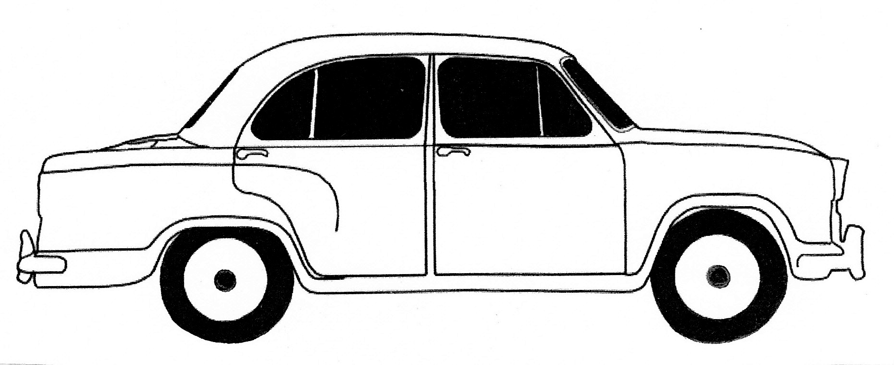
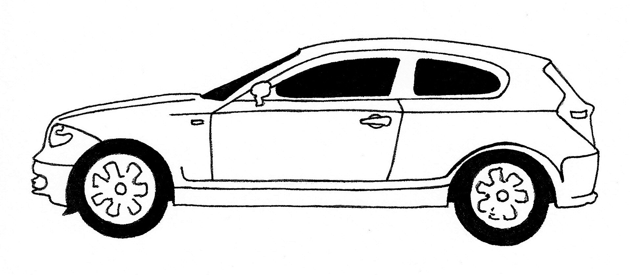
8.00 kg 12.0 m s⁻¹
5.00 kg 9.00 m s⁻¹

- Determine the velocity of the blue car after the collision. (2)
Let East = +ve,
m₁ = 8.00 kg u₁ = +12.0 m/s m₂ = 5.00 kg u₂ = -9.00 m/s v₁ = +2.50
ΣP_{before} = ΣP_{after} m₁u₁ + m₂u₂ = m₁v₁ + m₂v₂
(8.00 × +12.0) + (5.00 × -9.00) = (8.00 × +2.50) + (5.00 × v₂) ✓
v₂ = +6.20 m/s ✓ (+ = East)

- The kinetic energy of the cars after the collision is 121 J. Compare this with the kinetic energy of the cars before the collision. What conclusion can you make about energy transformations in the collision? (2)
KE before = _{½} m₁u₁² + ½ m₂u₂² = ½.8 × 12² + ½.5 ×(-9)² = 778.5 J✓

Kinetic energy has reduced. It has transformed to sound and heat. ✓
(The collision was inelastic)

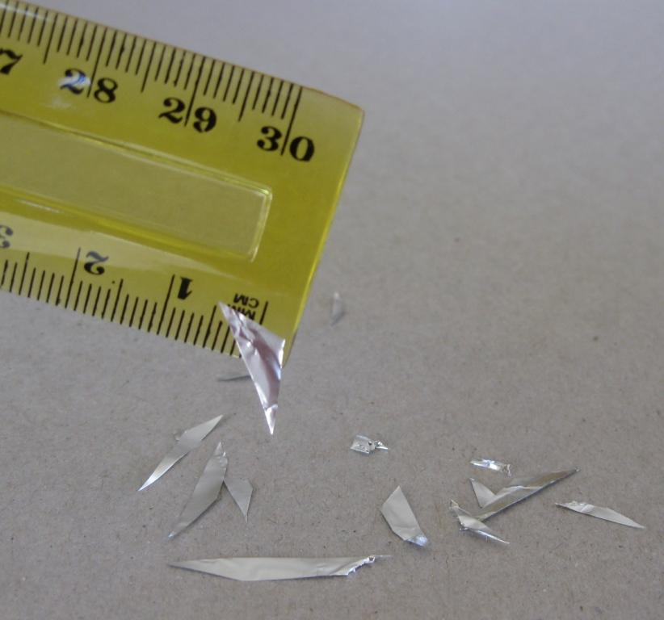
Question 10
A plastic ruler is rubbed with a cloth so that it becomes negatively charged.
The ruler is brought next to some small pieces of aluminium foil.
The pieces of aluminium are attracted to the ruler and ‘stick’ to it.
- Explain how the ruler can become negatively charged. (2)

It has an excess of electrons. ✓ Electrons transferred from the cloth to the ruler. ✓ (Leaving cloth with a net positive charge).

- Explain, with reference to electrostatic principles, how the aluminium pieces can ‘stick’ to the ruler. You can use the picture to assist your answer.
(2)
Electrons in aluminium are delocalised and free to move. They are repelled by charge in fixed location on the plastic ruler (an insulator) ✓
This leaves an area of positive charge on the aluminium closest to ruler which leads to electrostatic attraction. ✓

Question 11 [2]
Fill in the blanks to complete the following sentences:

- Heat transfer by the process of radiation is primarily by the __Infra Red_ portion of the electromagnetic spectrum.

- The process of heat transfer within the atmosphere above a desert that leads to wind formation is called ___Convection_
- Heat loss by the process of _Radiation_ _____ from a thermos flask can be minimized by the double layered glass wall in the flask. The glass is silvered with a vacuum between the layers.
- The air pockets trapped between the fibres of a woollen jumper minimize heat transfer because air is a poor _Conducter_________ of heat.
4 = 4 marks 3 = 2 marks 2 = 1 marks 1/0 = zero

Question 12 [2]
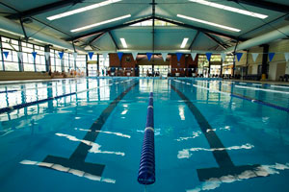
A member of staff at a swimming pool opens a container of a chlorine based liquid cleaning chemical.

Within a few seconds his co-worker can smell the chlorine even though she is standing several metres away.

This observation is evidence of the particle nature of matter in Kinetic Molecular Theory. Explain why.

This is explained by concept of all matter made of vibrating particles with space between them. ✓
Particles of chlorine phase change by evaporation at surface and by collisions can intersperse between air molecules to travel through the room. ✓ (Diffusion)
Or similar.

Question 13 [4]
One possible fission reaction of Uranium-235 proceeds as follows:

Mass of Rubidium-95 nucleus: 94.909022 u
Mass of Caesium-137 nucleus: 136.876912 u

Calculate the energy released in this reaction. You must work in atomic mass units and electron volts for this question.
Mass of reactants = 234.993454 + 1.00867 = 236.002124
Mass of daughter products = 94.909022 + 136.876912 + (4×1.00867)
Mass of daughter products = 235.820614 ✓
Δm = 236.002124 - 235.820614 = 0.18151 u ✓

E (MeV) = Δm (u) × 931
E = 0.18151 × 931 ✓ = 168.98581
E = 169 MeV ✓

Question 14
A proton is at rest in the space between 2 charged plates. One plate is positive the other negative and the potential difference between them is 18.0 V.
+
+
+
+
+
+
+
+
-
-
-
-
-
-
-
-
+

- Sketch a uniform electric field between the 2 plates.
(1)
- Calculate the maximum speed that the proton can reach in this potential difference. (Hint – work is done by the force field as kinetic energy is transformed into the charged particle)
(3)
q = -1.60 × 10⁻¹⁹ C V = 18.0 V m_{proton} = 1.6726 × 10⁻²⁷ kg (data sheet)
KE_{initial} = 0 KE_{final} = ½ m v² ✓
(use absolute value of charge as v is scalar)

W = q.V = ΔKE = KE_{final} - KE_{initial}
q.V = ½ m v²
1.60 × 10⁻¹⁹ × 18.0 = ½ × 1.6726 × 10⁻²⁷ × v² ✓
v² = 3.44374 × 10⁹ so v = 5.87 × 10⁴ m s⁻¹ ✓

Question 15
When a patient receives nuclear medicine treatments in a hospital, their absorbed dose must be carefully monitored.

- Explain why nuclear radiation can be harmful to the human body.
(2)
When radiation (alpha, beta or gamma) interact with human cells energy is transferred into the atoms that make up the cell. This may cause damage by burns or by ionisation. Ionisation can lead to DNA mutations (cancer / reproduction problems) or cell death. ✓✓

- A ‘quality factor’ is applied to different types of radiation. Explain why.
(2)
The cell damage caused by alpha, beta or gamma varies for equal amounts of energy absorbed (absorbed dose). The quality factor scales the effect with reference to gamma radiation to provide a ‘dose equivalent’. (Or similar) ✓✓

Question 16 [3]

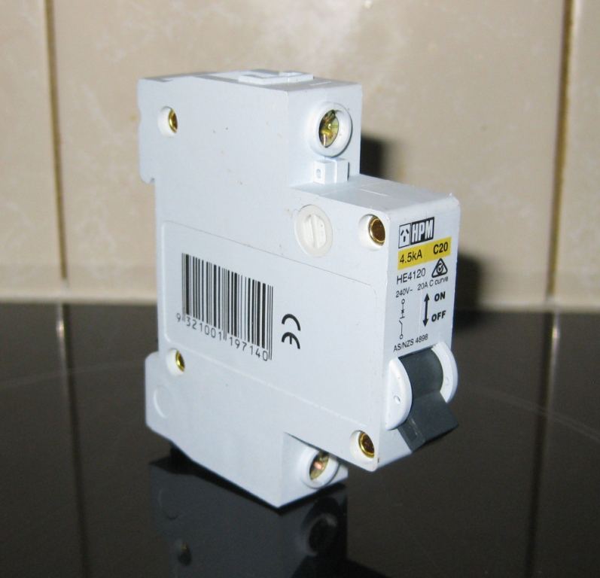
A household electrical circuit includes components that protect people when using electrical devices. The fuse has now been replaced by circuit breakers and residual current devices in new homes.

Choose either a ‘circuit breaker’ or a ‘residual current device’ and describe how it protects people from electric shock and why it is better than a fuse.
Circuit breaker – if current higher than the rating of the component is detected the circuit breaker uses electromagnetic effects to switch off the circuit in a very short time. It can easily be reset by the switch on the front.

RCD – monitors the current in active and neutral wires which should be identical. In case of a fault or electrocution occurring there will be a difference. Electromagnetic properties cause the RCD to switch off the circuit within a few milliseconds. Can be easily reset.
Look for 3 good points. ✓ ✓ ✓

Question 17
4 resistors are connected in a complex circuit to a 38.0 volt battery.
19 Ω
24 Ω
8.0 Ω
P
5.4 Ω
Q

38.0 V

- Determine the total resistance of the 4 resistors between points P and Q in this circuit.
(3)
Resistance of the parallel group Total Resistance
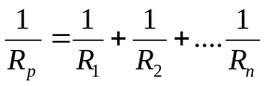 R_{T} = R₁+R₂+…..R_{n}

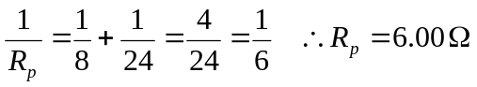 R_{T} = 5.40 + 19.0 + 6.00
✓ ✓ R_{T} = 30.4 Ω ✓

- Determine the potential difference across the 5.40 Ω resistor in this circuit.
(3)
R_{total} = 30.4 Ω V_{emf} = 38.0 V V = I.R
I = V / R = 38.0 / 30.4 ✓ I = 1.25 A ✓

V_{d} = I.R = 1.25 × 5.40 = 6.75 V ✓

- Calculate the power rating of the 5.40 Ω resistor
(1)
R = 5.40 Ω I = 01.25 A P = ?
P = I².R (or P = I.V_{d} = 1.25 × 5.40 or P = V_{d}²/R = 6.75² / 5.40)
P = 1.25² × 5.40 = 8.4375 P = 8.44 W ✓

- Calculate how much electrical energy is transformed by the 5.40 Ω resistor in a time of three minutes, assuming it is an ohmic conductor.
(1)
t = 3 × 60 = 180 s
E = P × t (or E = V_{d}.I.t)
E = 8.4375 × 180 = 1518.75 ✓ E = 1.52 × 10³ J ✓

End of Section One
Section Two: Problem-solving 50% (80 Marks)

This section has seven (7) questions. Answer all questions. Write your answers in the space provided. Suggested working time for this section is 90 minutes.

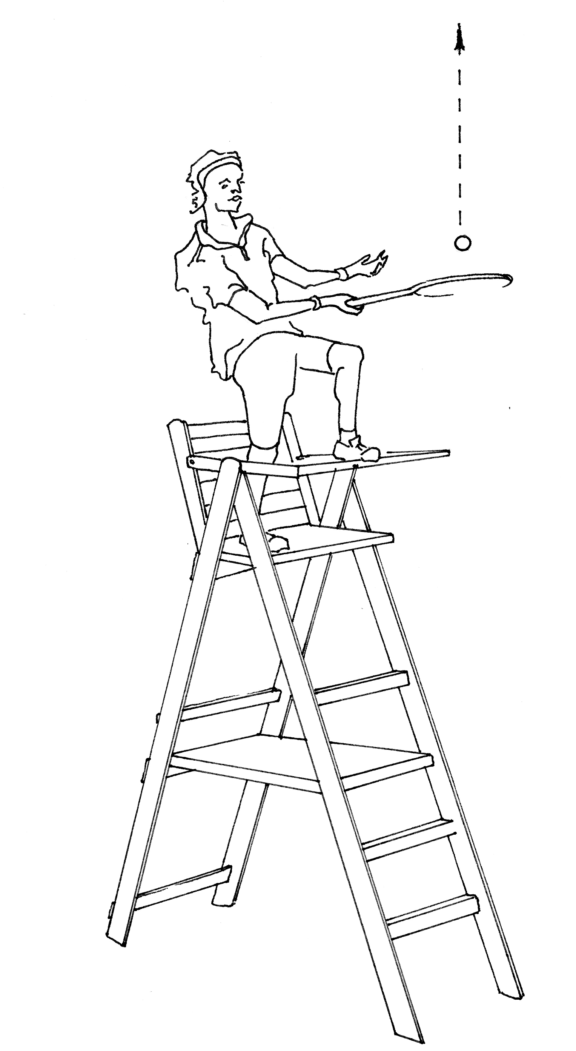
Question 1 [12 marks]
3.80 m

Rafael Nadal celebrates his Wimbledon victory by climbing onto the top of the umpire’s chair and smashing a tennis ball vertically upwards.

The ball is launched from a position 3.80 m above the ground with an initial velocity of 24.2 m s⁻¹ upwards.

The ball has a mass of 56.7 grams.

You may ignore air resistance in this question.

- Calculate the maximum height that the ball reaches above the ground.
Let up + +ve

u = +24.2 m/s a = -9.8 m/s² v_{max} = 0 s = ?

v² = u² + 2.a.s
0 = 24.2² + (2 × -9.8 × s) ✓
s = -24.2² / -19.6
s = 29.879.. ✓

s_{above ground} = 29.879 + 3.80 = +33.7 m ✓
(3)

- Calculate the velocity of the ball after 3.10 seconds.
(2)
Let up + +ve

u = +24.2 m/s a = -9.8 m/s² v = ?

v = u + a.t
v = 24.2 + (-9.8 × 3.10) ✓
v = -6.18

v = -6.18 m/s (negative indicates down) ✓

- Calculate the flight time of the ball (the time taken for the ball to leave the racquet and reach the ground).
(4)
Let up + +ve u = +24.2 m/s a = -9.8 m/s² s = -3.80

v² = u² + 2.a.s
v² = 24.2² + (2 × -9.8 × -3.80) ✓
v² = 660.12
v = - 25.6928 ✓ (negative indicates going down)

v = u + a.t
- 25.6928 = 24.2 + (-9.8 × t) ✓
- 25.6928 - 24.2 = -9.8 × t
t = -49.8928 / -9.8 t = 5.09 seconds ✓

Alternatively general solution of a quadratic using s = ut + ½ at²
-3.80 = 24.2t – 4.9t²
-4.9t² + 24.2t +3.80 = 0 (a = -4.9, b = 24.2, c = 3.80) to solution.

- Calculate the kinetic energy of the ball at the instant it reaches the ground.
(3)
Let up + +ve u = +24.2 m/s a = -9.8 m/s² s = -3.80
m = 0.0567 kg

v² = u² + 2.a.s
v² = 24.2² + (2 × -9.8 × -3.80) ✓
v² = 660.12

KE = ½ m v²
KE = ½ 0.0567 × 660.12 ✓

KE = 18.7 J ✓

Question 2 [12 marks]

- Some liquid alcohol of mass 0.65 grams was placed in a glass container and vaporised at 70ºC. The container with the vapour was placed in a large water bath that was kept at room temperature. The change in temperature of the alcohol was recorded for 1 minute. There was constant rate of energy output from the alcoholic substance such that 1165 J of energy was transferred out in a 50 second time period. The graph below shows the cooling curve produced. Assume that heat loss to the surroundings was negligible.
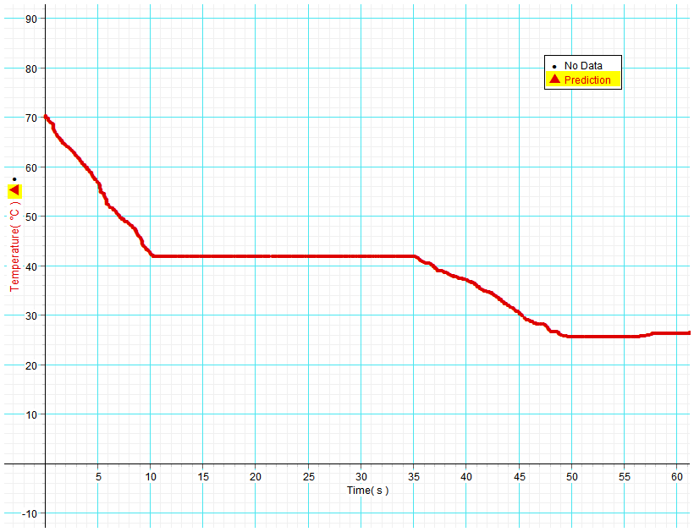
A
B
C
D
Cooling curve of alcoholic substance.

- From the graph, what comparison can you make between the specific heat capacity of the liquid alcohol versus the specific heat capacity of its vapour? No calculation is required.
(2)
C(vapour) is less than C(liquid) as seen from the steeper gradient of the vapour. ✓ The drop in temperature of the vapour occurs with less release of energy compared to the liquid. ✓ or similar

- What states of matter are present in the container during section BC? (1)
Vapour (gas) and Liquid ✓

- Determine the latent heat of vaporisation of the alcohol. (3)

Refers to graph to get 25 seconds of time for phase change
Q = 1165 J in 50 s which is 582.5 J in 25 s
m = 0.65 × 10⁻³ kg ✓

Q = m x L_{v}
i.e. L_{v} = Q / m = 582.5 / (0.65 × 10⁻³) ✓ L_{v} = 8.96 x 10⁵ J kg⁻¹ ✓

- In terms of the Kinetic Molecular Theory, explain why the temperature of the substance did not decrease while energy transferred from it to the water between 10 and 35 seconds. Define temperature as part of your answer.
(3)
At the condensation (boiling) point internal energy is released to water by a decrease in potential energy only. (Particle separation is reducing). ✓
The kinetic energy component of internal energy is unchanged. ✓
Temperature is a measure related to average kinetic energy of particles so this is constant.✓

- Consider ‘0.65 g of the vapour at 70°C’ and ‘10 kg of the liquid at 25°C’. Which of the two would you expect to have the highest internal energy? Discuss with reference to Kinetic Molecular Theory.
(3)
Internal Energy is the sum of all kinetic energy and potential energy of the particles that form the mass of a substance. ✓

Temperature is only related to the average kinetic energy regardless of the number of particles in a given mass of substance. ✓

The number of particles in 10 kg is vastly more than 0.65 g so internal energy of the 10 kg of liquid is likely to be much greater. ✓

Question 3 [11 marks]

A high speed electric train is tested on a track which is a straight line that runs from West to East. Motion sensors are placed along the track to investigate the motion. The data has been processed to make the velocity–time graph below. East is considered positive and the motion starts from the midpoint of the track.

Time (s)
Velocity (m s⁻¹)

Use the graph to determine the following information:

- For how many seconds in total was the train stationery?
(1)
6 seconds (from t = 22 to t = 28) ✓

- Determine the acceleration of the train between 12 and 15 seconds.
(2)
t = 3 Δv = final – initial = (-4) – (-19) = +15 from the graph ✓

a = Δv / t = +15 / 3 = +5.00 m s⁻² (+ indicates direction East) ✓

- What is happening to the speed of the train between 12 and 15 seconds?
(1)
The speed (scalar magnitude) is decreasing. ✓

- Determine the average velocity between 12 and 15 seconds.
(2)
u _{initial} = -19 m/s v _{final} = -4.0 m/s

v_{av} = (u+v) / 2 = (-19 + (-4)) / 2 = -11.5 m/s ✓
(- indicates direction West) ✓

- Determine the displacement of the train after 12 seconds.
(2)
Determines area bounded by graph and time axis
(½ × 6 × -19) + (6 × -19) ✓

Displacement = -171 m (negative equals West) ✓

- Between 12 and 15 seconds, did the train get further away from the reference point (the midpoint of the track) or closer to it? Explain briefly.
(1)

Further away from midpoint - it was slowing down but kept going in the same Westerly direction. ✓

- Has the train reached a position East or West of the start point after 40 seconds of motion? Justify your answer.
(2)
Consider area of positive displacement from 28 to 40 seconds
Area = 2( ½ × 4 × 20) + (4 × 20) = +160 m (positive equals East) ✓

This is less magnitude than 171 m from 0 to 12 seconds (plus a little more Westerly displacement from 12 to 22 seconds)

After 40 seconds the train is still West of the start point. ✓

Question 4 [13 marks]

The graph below shows the binding energy per nucleon versus mass number for the nuclei of some common isotopes.
Mass Number A
Binding Energy per Nucleon (MeV)

- In which nucleus do the protons and neutrons have the lowest mass? Circle the best response.
(1)
A. Constant mass in all nuclei B. Hydrogen-1 C. Lithium-6

D. Iron-56 ✓ E. Uranium-235 F. Uranium-238

- From the graph estimate the average binding per nucleon (MeV) of the Lithium-6 nucleus.
(1)
5.2 MeV per nucleon ✓ 5.1 to 5.3 acceptable

- Use your previous answer and data from the constants sheet to estimate the difference in mass between a Lithium-6 nucleus and the individual nucleons that go into making the nucleus. State your answer in atomic mass units.
(2)
BE = 5.2 MeV per nucleon number of nucleons = 6
Mass Defect = (BE per nucleon × number of nucleons) / 931 ✓
Mass defect = (5.2 × 6) ÷ 931 = 0.033512 u ✓

- Refer to the graph to explain which elements can undergo nuclear fusion and release energy. (1)
Elements to the left of iron-56 can combine by fusion and in doing so lose mass which is converted to energy. ✓

- There are several possible reactions that are being considered for nuclear fusion power plants in the future. One of them is the fusion of deuterium and lithium-6.
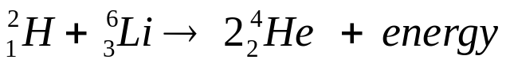

Mass of lithium-6 nucleus: 9.98561 × 10⁻²⁷ kg

- Calculate the energy (joules) released by this reaction. You must keep your units in kg and joules for this question.
(4)
Mass of reactants = 3.34358 × 10⁻²⁷+ 9.98561 × 10⁻²⁷ = 1.332919 × 10⁻²⁶
Mass of daughter products = 2 × 6.64466 × 10⁻²⁷ = 1.328932 × 10⁻²⁶ ✓

Δm = 1.332919 × 10⁻²⁶- 1.328932 × 10⁻²⁶= 3.987 × 10⁻²⁹ kg✓

E (J) = Δm.c²
E = 3.987 × 10⁻²⁹ × (3 × 10⁸)² ✓ = 3.5883 × 10⁻¹² J

E = 3.5883 × 10⁻¹² J ✓ (allow maximum significant figures here)

- Convert the energy you have calculated in joules to MeV.
(1)
E(Mev) = E (J) ÷ 1.60 × 10⁻¹³
E = 3.5883 × 10⁻¹² ÷ 1.60 × 10⁻¹³ = 22.426875 MeV ✓
(allow 3 or more significant figures)

- Give 2 reasons why nuclear fusion is ultimately seen as more desirable than fission.
(2)
Less quantity of hazardous radioactive by-products.
Readily available fusion materials.
Any 2 reasonable answers. ✓ ✓

- In what way is a nuclear power station similar to a power station that burns coal to produce electricity?
(1)
The burning/reaction of fuel is to generate large amounts of heat to turn water into steam that drives turbines. ✓

Question 5 [10 marks]

Railway engineers are testing a carriage. The carriage is propelled horizontally at 90.0 km h⁻¹ towards an inclined plane. Once propelled it is only under the influence of gravity. It then climbs the inclined plane until it stops. The carriage then returns along the track back to the start point.
The carriage has a mass of 850 kg. Air resistance and friction can be ignored in this question.
850 kg carriage 90 km h⁻¹
h = 19.0 m
Maximum height
Safety Barrier to stop carriage when it returns

- With reference to the principle of conservation of mechanical energy, calculate the speed of the carriage when it has reached a vertical height of 19.0 m.
(3)
Total Mechanical Energy = KE + GPE = constant
u = 90 / 3.6 = 25 m/s h_{i} = 0 h_{final} = +19.0 m m = 850 kg v = ?
g = field strength (taken as positive here so that increased height has greater magnitude of potential energy) = +9.8 N Kg⁻¹ ✓

½ m u² + m.g.h_{initial} = ½ m v² + m.g.h_{final}
½ 850 × 25² + (850 × 9.8 × 0) = ½ 850 × v² + (850 × 9.8 × 19) ✓
½ 25² = ½v² + (9.8 × 19)
v = 15.8933.. v = 15.9 m s⁻¹ ✓

- When the carriage arrives back at the start position it is travelling at 90 km h⁻¹ left and collides with a crumple zone safety barrier that brings it to rest in a time of 1.65 seconds. Determine the net force acting on the carriage in this collision.
(2)
u = -25 m/s v = 0 m = 850 kg Δt = 1.65 s

F.Δt = Δp = mv – mu

F × 1.65 = 850 (0 – (-25)) ✓

F = + 1.29 × 10⁴ N ✓ (direction of force = right)

alternatively a = (v-u) / t and F = m.a

- Determine the distance travelled by the carriage in this collision.
(2)
u = -25 m/s v = 0 m = 850 kg F = +12,878.78..N

W = ΔKE = F × s
-(½ m v²) = F × s
-( ½.850.-25²) = +12878.78 × s ✓
s = -20.625 m (left) s = 20.6 m ✓

- What has happened to the energy associated with the motion of the carriage during this collision?
(1)
By the principle of conservation of energy it has been converted to other energy forms such as heat and sound. ✓

- If the collision with the safety barrier occurred over a shorter time, the force acting on the carriage would be a: (circle a response) (1)

greater magnitude equal magnitude lesser magnitude impossible to determine

- If the collision with the safety barrier occurred over a shorter time, the distance required to stop the carriage would be a: (circle a response) (1)

greater magnitude equal magnitude lesser magnitude impossible to determine

Question 6 [9 marks]

An electrician must design a security circuit to run two light globes at their design voltages when connected to a 33.0 V battery.
R₂
R₁
P
Q
R
EMF 33.0 V DC
globe 1
globe 2
V
A

Globe 1 is rated at 30 V, 96 W Globe 2 is rated at 10 V, 16 W

- Calculate the current through Globe 1 and Globe 2 when operating at their rated voltages.
(2)
P = I.V I = P / V = 96 / 30 = 3.20 A ✓

I = P / V = 16 / 10 = 1.60 A ✓
Globe 1

Globe 2

- What should the reading on the ammeter be? (1)
I = 3.20 + 1.60 = 4.80 A ✓

- What should the reading on the voltmeter be? (1)
30.0 V ✓

- Calculate the resistance of R₂ required so that Globe 2 can work correctly.
(2)

Potential difference across R₂ = 30.0 – 10.0 = 20.0 V ✓
I = 1.60 A

R = V / I

R = 20.0 / 1.60 = 12.5 Ω ✓

- Calculate the resistance of R₁ required in the circuit.
(2)

Potential difference across R₁ = 33.0 – 30.0 = 3.00 V
I = 4.80 A

R = V / I

R = 3.00 / 4.80 ✓ = 0.625 Ω ✓

- What is the effective resistance of the ammeter in this ideal circuit?
(1)
Zero ohms ✓

Question 7 [13 marks]

A group of engineering students are studying the rate of energy emitted by heat radiation from an engine block. They are able to detect the amount of radiation transmitted from the engine by sensors placed on the walls, floor and ceiling of the test room.

The engine block is taken to a given temperature and the power (or energy emitted per second) is measured. The students have recorded sets of data for temperature (K) and Power (W) in the table below.

Engine block of surface area A = 0.396 m²

The students are using a simplified version of the Stefan-Boltzmann radiation equation:

e = emissivity (a value from 0 -1 that indicates ability to emit radiation)
P = power (W) T = temperature (K) A = surface area of block (m²)
σ = the Stefan-Boltzmann constant = 5.67 × 10⁻⁸ J s⁻¹ m⁻² K⁻⁴

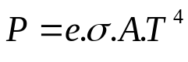

They have justified the use of this version of the equation because the surrounding walls, ceiling and floor are designed not to radiate energy back to the engine block.

One of the primary objectives is to determine the emissivity value (e) of the engine block.

The students decide to graph power on the y-axis versus Kelvin temperature to the power 4 (T⁴) on the x-axis. This will ‘linearise’ the data into a y = m.x + c format, such that the gradient of the line of best fit equals an average value of (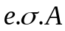).

Results table:
Temperature (K) | Temperature⁴ (K⁴) | Power (W)
360 | 1.68 ×10¹⁰ | 290
400 | 2.56 ×10¹⁰ | 435
440 | 3.75 ×10¹⁰ | 640
480 | 5.31 ×10¹⁰ | 900
520 | 7.31 ×10¹⁰ | 1240
560 | 9.83 ×10¹⁰ | 1680

- What is the independent variable in this experiment?
(1)
(Kelvin) Temperature ✓

- Fill in the missing values in the table. (Follow the format of the first value which has been done for you)
(2)
Correct calculations ✓ Follows format ✓

- Plot your data points onto the graph paper. Include all appropriate axes labels and units and draw a straight line of best fit through your data points.
(5)

Run = 9.4 – 1.2 = 8.2 (× 10¹⁰ K⁴)
Rise = 1600 – 200 = 1400 (W)
Correct axis scaling ✓
Correct plotting of data ✓
Correct axis labels ✓
Correct axis units ✓
Appropriate line of best fit through data ✓

- Determine the gradient of your line of best fit with careful reference to the units on each axis.
(3)
Gradient = Rise / Run (must clearly refer to the line of best fit and not just 2 data pairs from the table) ✓
Gradient = (1400) / (8.2 × 10¹⁰ ) ✓ Gradient = 1.71 × 10⁻⁸ W K⁻⁴ ✓

- Substitute values to determine the value of emissivity (e) of the engine block. (If you were unable to determine the gradient of the graph use a value of 1.70 × 10⁻⁸)
(2)
gradient = e.σ.A
e = gradient / σ.A

e = 1.70 x 10⁻⁸ / (5.67 x 10⁻⁸ x 0.396) ✓= 0.757 ✓

End of Section Two

Section Three: Comprehension 10% (16 Marks)

This section contains one (1) question. You must answer this question. Write your answer in the space provided. Suggested working time for this section is 20 minutes.

Solar Cells – converting sunlight into electricity

In the midst of the debate about global warming and obvious problems such as the disastrous BP oil spill in the Gulf of Mexico this year, alternatives to coal, oil and gas are urgently sought. Clean, renewable energy is a vision shared by many.

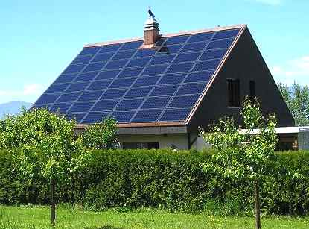
An energy source that is increasingly viable is from Solar Cells that convert sunlight into electricity. You may have seen arrays of solar panels on rooftops in Perth. So how do they work?

A basic explanation is as follows. The solar cell consists of 2 thin layers of a semiconducting material such as silicon which have different electrical properties. Many cells are spread over a large surface area in a panel. Sunlight shines onto the panel and light energy is transferred to electrons within the silicon. These electrons can be driven through an external load with the solar panel acting as a source of emf.

The electrical conduction properties of a semiconductor such as silicon are altered by adding impurities in a process known as ‘doping’. An n-type semiconductor is made by adding atoms such as arsenic which give the semiconductor an excess of free electrons. A p-type semiconductor is doped with materials such as aluminium or indium which give the semiconductor a deficiency of electrons known as ‘holes’.
Load resistor
A thin upper layer of n-type semiconductor is bonded to a layer of p-type semiconductor
n-type material
p-type material
electrical contacts
Electrons from the n-type material fill into holes of the p-type material near the junction
Atomic electrons energised by sunlight follow an external path from n to p

Consider a solar cell when no sunlight shines on it. At the junction between the n-type and p-type materials, electrons from the n-type migrate into the holes of the p-type, this leaves the n-type layer with a net positive charge and the p-type layer with a net negative charge. An electric field is established across the junction. The field strength increases until equilibrium is reached making it harder for electrons to cross from the n-side to the p-side. Now the electric field behaves like a ‘diode’ which only allows other electrons to cross in the direction p to n.

When sunlight shines onto the solar cell, a photon of light absorbed near the junction can free an electron in the atomic structure and leave a positive hole. This free electron is forced across the junction to the n-type layer and the hole effectively moves to the p-type layer by successive electrons filling the hole but forming another hole where they came from. If an external conducting path with a load resistance is connected between the n-type layer and the p-type layer then electrons will flow from the n-type layer through the external path and back to the p-type layer to fill into a hole.
P_{max}

The graph shows the typical electrical output characteristics for a solar cell in Perth. The maximum power for ‘January full sunlight’ is indicated by P_{max}.

Maximum power from a solar cell is achieved by carefully setting the load resistance. When load resistance is too high a high voltage can be achieved but only with very low current. A low resistance can maximise current but the voltage will be much lower.

When purchasing solar panels there are important factors to consider. The high cost means that it can take many years to pay back the financial outlay. Reliability is critical although many manufacturers now offer a 25 year warranty. The cells supply DC but household items run on AC so an ‘inverter’ is needed for the conversion. Western Power like many other utilities will now buy excess electricity produced by a solar powered household, so this along with government subsidies can make a purchase feasible.

Questions

- Explain how a semiconductor such as silicon can be made to have an excess of free electrons
(2)
To make an n-type semiconductor impurities ✓such as arsenic are added to the silicon ✓

- What is the net electrical charge of a ‘hole’? Circle the correct response. (1)

A. Neutral B. Positive C. Negative D. Positive or negative depending on location

- Explain how a ‘hole’ can effectively move through the atomic structure of silicon.
(2)
An electron fills into a hole but in doing so leaves a hole where it came from. This hole is filled by an electron leaving another hole. ✓ This process continues and can be viewed as a hole moving backwards. ✓ (or similar)

- What is the direction of conventional current through an external load resistor connected to the cell?
(2)
From the p-type layer at the bottom through the external path to the n-type layer on top. ✓ ✓

- Use the graph to estimate the maximum power output of a solar cell in January full sunlight. Clearly indicate how you obtained data from the graph.
(3)
obvious graph reference ✓
emf = 0.435 V (+/- 0.01) I = 1.24 A (+/- 0.01) ✓
P = V.I
P = 0.435 × 1.24 = 0.5394 P = 0.539 W ✓

- Refer to the 3 curves on the graph for this question and circle the best response.
For an output voltage of 0.1 V the load resistance is -
(1)
A. Too high in all cases B. Too low in all cases

C. Could be either depending on sunlight D. Impossible to determine

- Solar panels supply DC. What problem does this cause when feeding electricity back to the Western Power grid and how is this problem solved?
(2)
Western Power grid is AC. ✓This is solved by use of an inverter which converts the DC into an AC waveform. ✓

- A typical solar panel is 18% efficient in terms of converting the energy in sunlight to electrical energy. Calculate the amount of solar energy required per second for a solar panel with an electrical output of 432 W.
(3)
432 W = 18% of 100% of energy per second supplied by solar energy ✓

Efficiency (%) = (energy taken / energy offered) × 100
0.18 = 432 / Solar energy ✓

Solar energy = 432 / 0.18 = 2400 Joules per second ✓

End of questions

